CompanyActivity | Category | Detail
 | COVID-19 Info | Reliable accurate information on the situation
 | Mental Health | Online counselling and talking therapy
 | Mental Health | Online counsellor chat, information around coping techniques
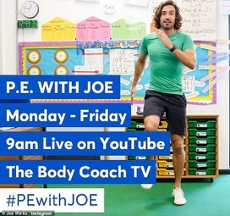 | Fitness | PE for Kids. Mon-Fri from 23/3/20 @ 9am on Youtube, plus lots of free workouts - The Body Coach TV pl
 | Activities | Activities, crafts, games, experiments
 | Fitness | App for workouts. Yoga, barre, HIIT. Free until 1st April AND free for all students and teachers (K-12 and college) until 1st July. To access the free school membership, please register your school's domain by visiting downdogapp.com/schools.
 | List | Virtual tours feature museums and other online learning courses
 | Games | Multiplayer board games online
 | Fitness | App for workouts
 | Fitness | App for workouts
Islington Library | Reading | Can borrow e-books and e-magazines etc
 | Activities | All the ideas
 | Art | Wild Art competition, submit by 28th August 2020
 | Art | Art competition, submit by 30th May 2020
 | Writing | Writing challenges, tools and resources
Yoga with Adriene | Fitness | Yoga channel, recommended by yoga teacher at Platform
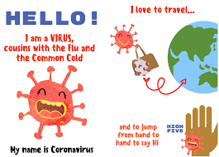 | COVID-19 Info  #COVIDBOOK | Child friendly explanation in multiple languages
 | Educational | Resources (some free) for learning support
 | Quiz | Answer questions on various topics to donate to the World Food Programme
 | Writing | Competition, submit by 19th April
 | List | List of writing competitions
 | Mental Health | Dealing with conflict at home during self-isolation
 | Educational | Online talks on a range of interesting subjects
 | Fitness | Movement and wellbeing for younger children
Stories for children and families. audible | Reading/listening | Stories for children and families online for free
 | Educational | Free online courses, some with certificates, on a range of subjects
 | Fitness | 60 day challenges, 10am each day on Facebook
 | Instagram live Boxing fitness and young people support | Instagram live Boxing fitness and young people support
 | Mental Health | Helps young people manage their feelings around self-harm
 | Mental Health | Play a game and grow your resilience
 | Mental Health | App for meditation and sleep
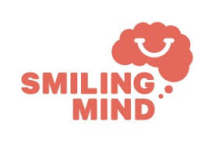 | Mental Health | App for meditation and mindfulness
 | Mental Health | Tracker for understanding everyday emotional wellbeing
 | Mental Health | Resources for those with anxiety disorders, and a telephone line and email contact
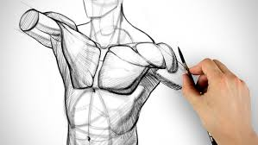 | Art | Suggestions for youtube channels by artists
Museum Virtual Tours | Museums | Museum virtual tours
 | Educational | Various podcasts
 | Music, Dance | Free broadcasts of performances
 | Support for Domestic Abuse | Free healpline and support for all experiencing domestic Abuse
 | Support for Domestic Abuse | Free healpline and support for all experiencing domestic Abuse
 | Reporting any crime anonymously, online or via phone | Reporting any crime anonymously, online or via phone

