‘Show My Homework’
- Greatfields uses Show My Homework across all subjects
- Online app
- Parents, students and teachers can all log in
- Notifications on child’s performance
- Schools using Show My Homework have seen 90% increase in student engagement with homework

Where to find SMHW
- School website
- Or phone app: Apple Store, Google Play
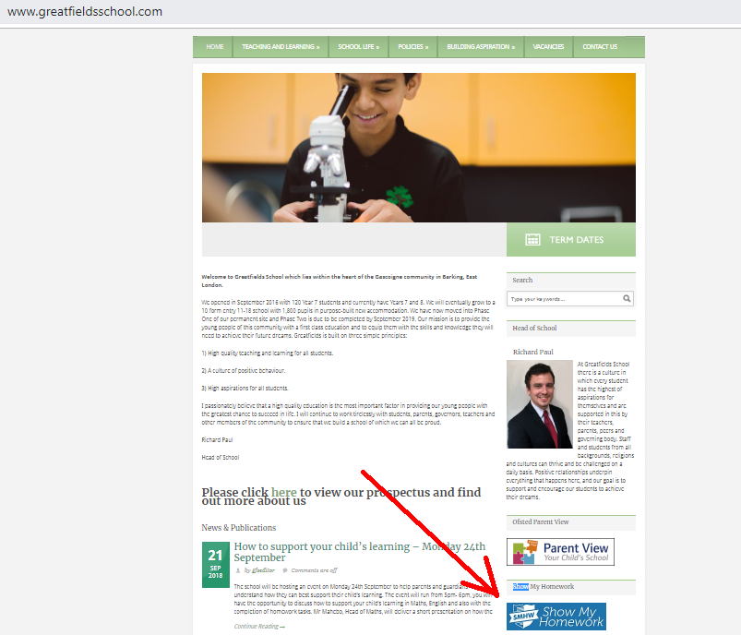

Logging in
- Click on the link on the school website
- First you need set up your account
- ‘I’ve been given a PIN or Parent Code’
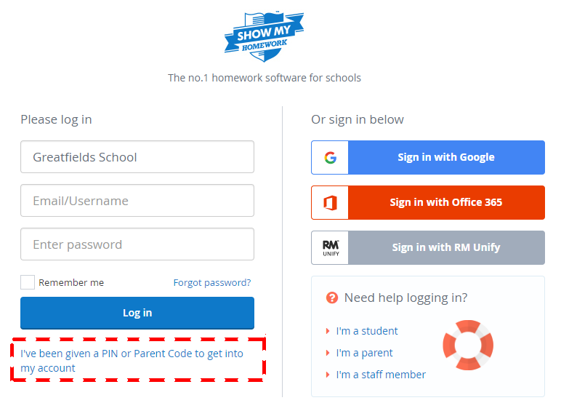

- Enter school name and your Parent Code
- Code was sent to you in a letter
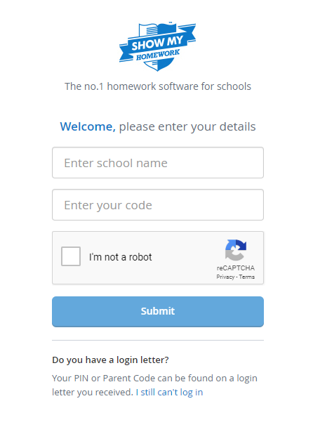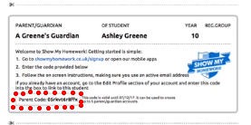

- Enter your details
- Set a password
- Confirm
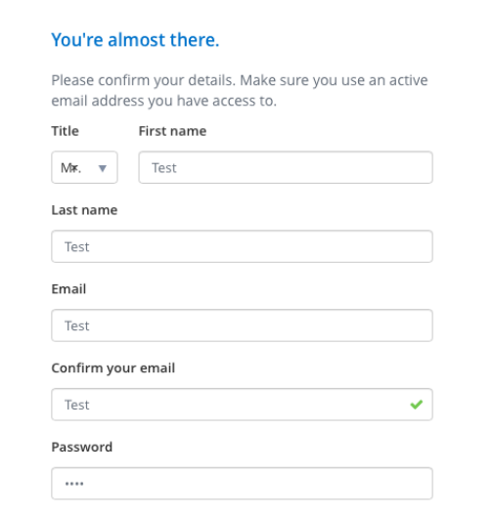

Using Show My Homework

- Now you are logged in
- To add another child
- ‘Account Settings’
- Enter Parent Code for that child 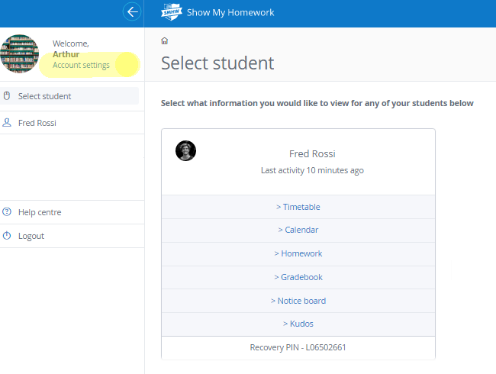

- You can see when child last used Show My Homework

Calendar Tab

- Shows current homework for all subjects
- Click on a piece of homework for more information
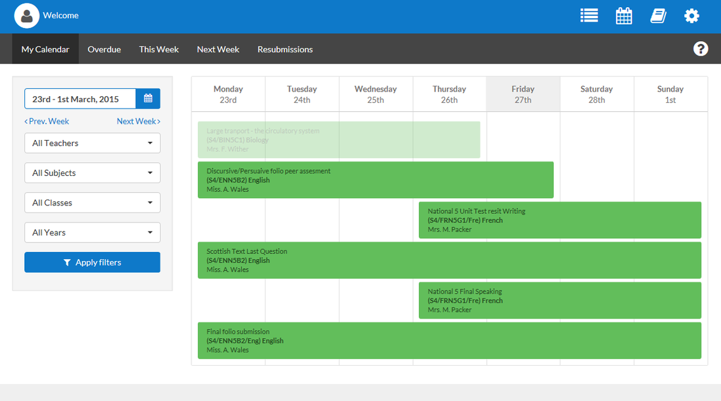

Homework Tab
- Can also show in list
- Shows date homework is due for
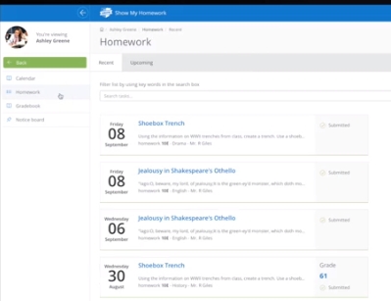

Gradebook Tab
- Can view grades of submitted homework
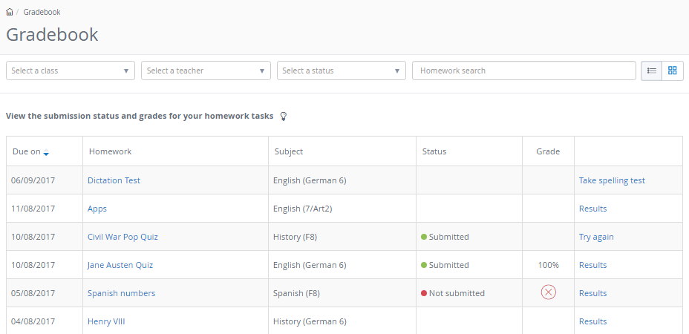

Notice Board Tab
- Any notices or announcements about homework
